* **GROUP 8, OCT-2021**
* **QUESTION1** -What is the major reason people being kidnapped in each and every state?

***SOLUTION*** –

SQL QUERY-

**SELECT * from(select Area_Name,Group_Name,sum(K_A_Cases_Reported) as total_case from Specific_purpose_of_kidnapping_and_abduction  
GROUP by Area_Name, Group_Name order by sum(K_A_Cases_Reported) DESC) group by Area_Name order by total_case desc**

RESULT OF QUERY:-

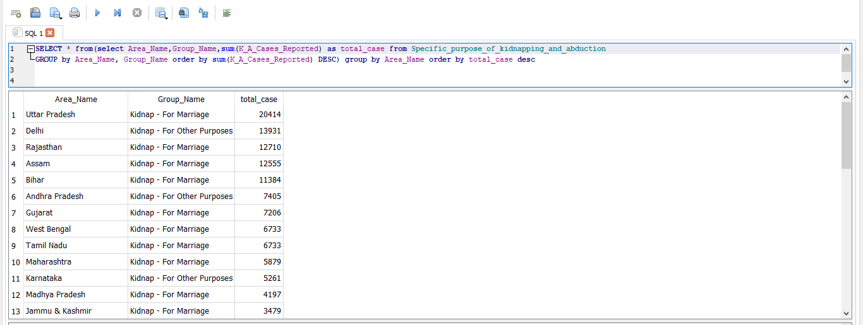

Visualization-

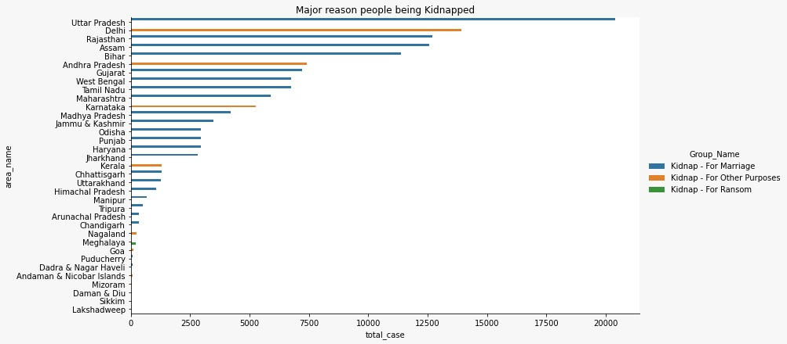

Conclusion-

* We can see by this graph ,highest numbers case of kidnapping in Uttar Pradesh.
* The reason of kidnapping is marriage.
* **Question2**- Offenders relation to the rape victim?

***SOLUTION***-

SQL QUERY-

**SELECT sum(No_of_Cases_in_which_offenders_were_Neighbours) as Neighbour,sum(No_of_Cases_in_which_offenders_were_Other_Known_persons) as others_known_person,  
sum(No_of_Cases_in_which_offenders_were_Parentsclose_family_members) as Parentsclose_family_members ,sum(No_of_Cases_in_which_offenders_were_Relatives) as offenders_were_Relatives,  
sum(No_of_Cases_in_which_offenders_were_known_to_the_Victims) as known_to_the_Victims from Offenders_known_to_the_victim**

RESULT OF QUERY:-

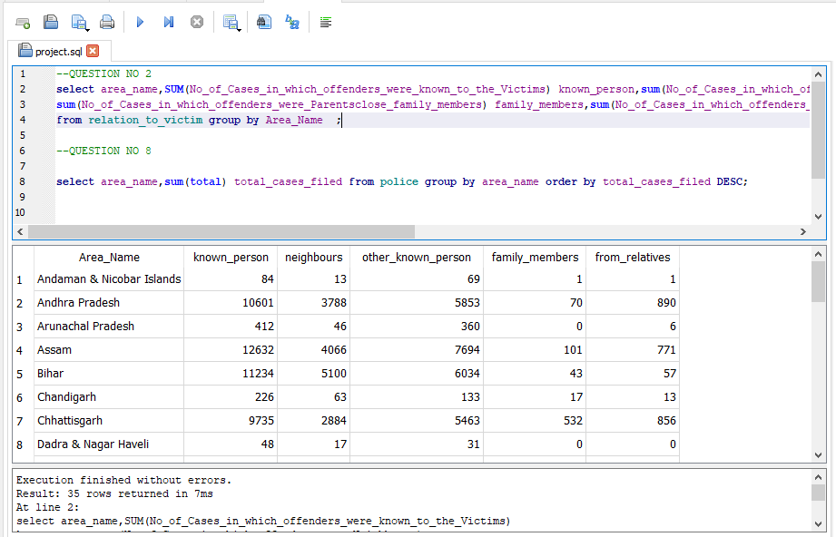

Visualization-

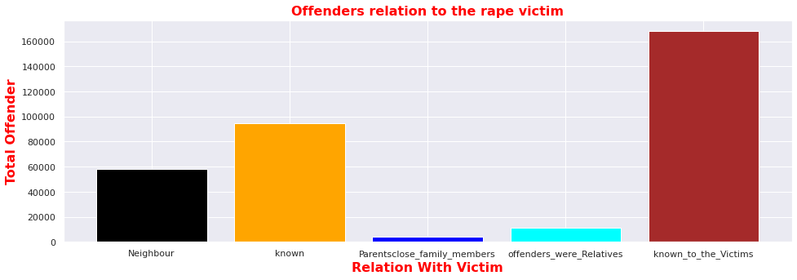

Conclusion-

* We can see by this graph, most cases where offenders were known to victim.
* **Question3**- Juveniles family background, education and economic setup.

***SOLUTION***-

SQL QUERY-

**SELECT d.Area_Name , e.income_upto_25k , e.income_25k_50k , e.income_50k_1L ,e.income_1L_2L , e.income_2L_3l , e.income_above_3L , f.homless , f.living_wd_guardians , f.living_wd_parents , d.illetrate , d.upto_Primary , d.below_higerSecondary , d.higher_secondary_above FROM (SELECT sum(Family_back_ground_Homeless) as homless,  
sum(Family_back_ground_Living_with_guardian) as living_wd_guardians,  
sum(Family_back_ground_Living_with_parents) as living_wd_parents ,Area_Name  
FROM Juveniles_arrested_Family_background  
GROUP BY Area_Name ) as f  
join  
(SELECT sum(Economic_Set_up_Annual_Income_250001_to_50000) as income_25k_50k,  
sum(Economic_Set_up_Annual_Income_upto_Rs_25000) as income_upto_25k,  
sum(Economic_Set_up_Middle_income_from_100001_to_200000) as income_1L_2L,  
sum(Economic_Set_up_Middle_income_from_50001_to_100000) as income_50k_1L ,  
sum(Economic_Set_up_Upper_income_above_Rs_300000)as income_above_3L,  
sum(Economic_Set_up_Upper_middle_income_from_200001_to_300000)as income_2L_3l,Area_Name  
FROM Juveniles_arrested_Economic_setup  
GROUP BY Area_Name  
) as e  
ON  
f.Area_Name = e.Area_Name  
JOIN  
(SELECT sum(Education_Illiterate) as illetrate ,  
sum(Education_Upto_primary) as upto_Primary,  
sum(Education_Above_Primary_but_below_Matric_or_Higher_Secondary) as below_higerSecondary,  
sum('Education_Matric_or_Higher_Secondary_&_above') as higher_secondary_above,  
Area_Name  
FROM Juveniles_arrested_Education  
GROUP BY Area_Name**  
**) as d  
ON e.Area_Name = d.Area_Name**

RESULT OF QUERY:-

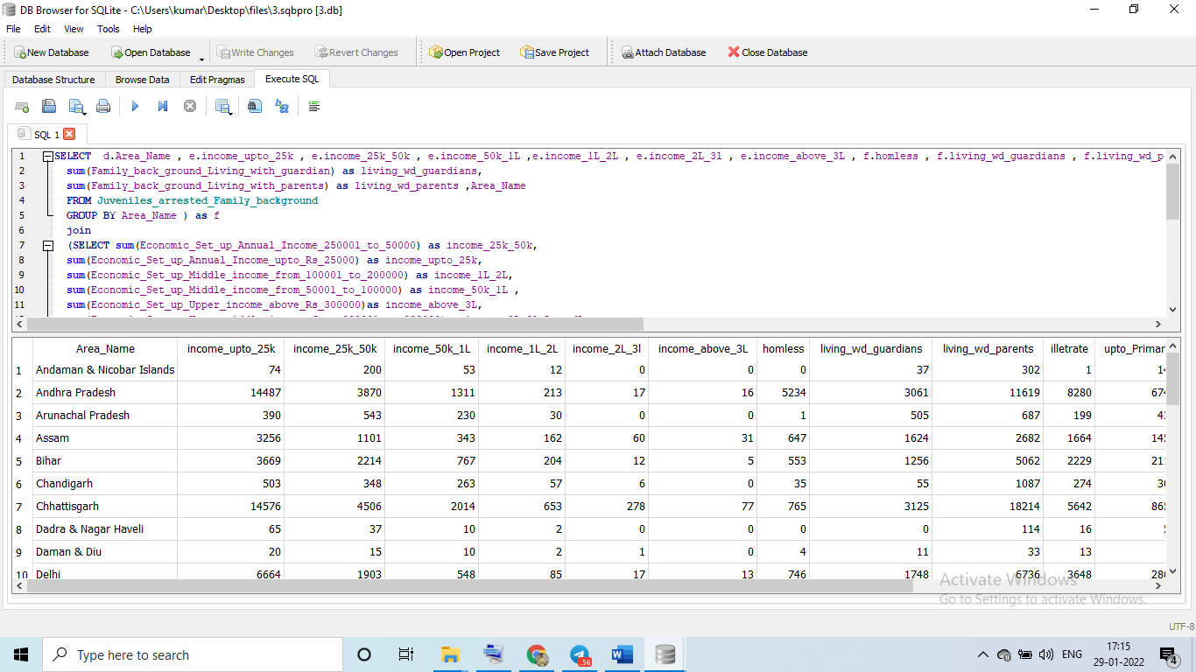

Visualization-

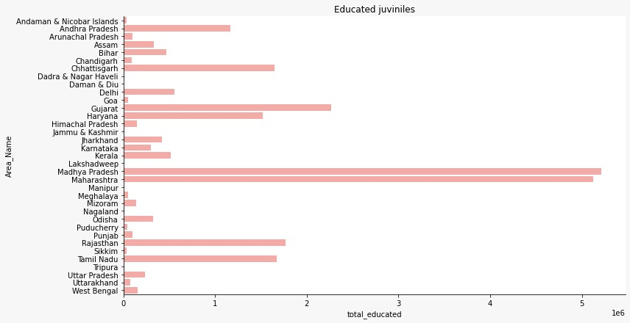

Conclusion-

* By this graph we can see highest educated juveniles in Madhya Pradesh .
* **Question4**- Which state has more crime against children and women?

***SOLUTION***-

SQL QUERY-

**SELECT c.STATE_UT,w.total_crime_on_women as crime_on_women ,c.total_crime_on_children as crime_on_children,(w.total_crime_on_women+c.total_crime_on_children) as Total_Crime  
from(SELECT STATE_UT,(sum(rape)+sum(KidnappingandAbduction)+sum(DowryDeaths)+sum(Assaultonwomenwithintenttooutragehermodesty)+sum(InsulttomodestyofWomen)+sum(CrueltybyHusbandorhisRelatives)+sum(ImportationofGirls)) as total_crime_on_women  
from crime_against_women_2001_2012  
GROUP by STATE_UT order by total_crime_on_women DESC) as W  
join (SELECT STATE_UT,sum(total) as total_crime_on_children from crime_against_children_2001_2012  
GROUP by STATE_UT order by sum(total) desc)as C on c.STATE_UT=W.STATE_UT ORDER by (w.total_crime_on_women+c.total_crime_on_children) DESC**

RESULT OF QUERY:-

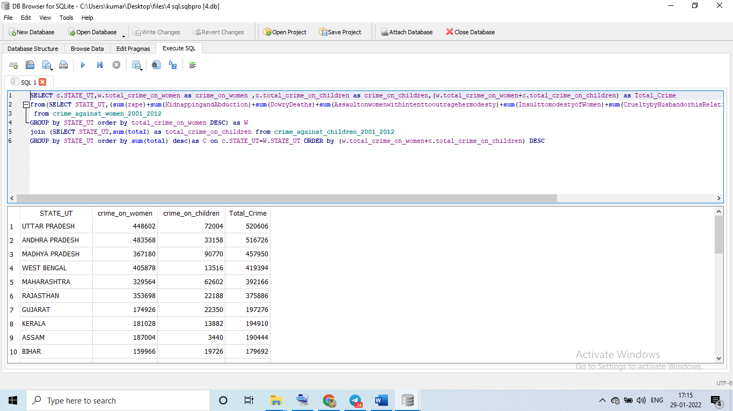

Visualization-

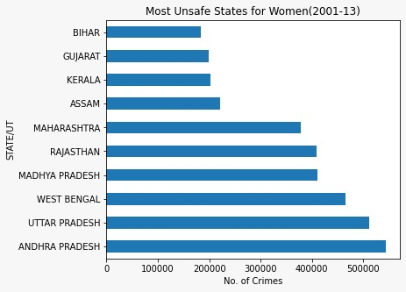

Conclusion-

* Andhra Pradesh have highest case against women.
* graph Uttar Pradesh have highest case against children.
* **Question5**- Age group wise murder victim?

***SOLUTION***-

SQL QUERY-

**select sum(Victims_Above_50_Yrs)as total_Above_50Yrs,  
sum(Victims_Upto_10_15_Yrs) as total_Victims_between_10to15Yrs,  
sum(Victims_Upto_10_Yrs) as total_Victims_Upto_10_Yrs,  
sum(Victims_Upto_15_18_Yrs) as total_Victims_Upto_15_18_Yrs,  
sum(Victims_Upto_18_30_Yrs) as total_Victims_Upto_18_30_Yrs,  
sum(Victims_Upto_30_50_Yrs) as total_Victims_Upto_30_50_Yrs from Murder_victim_age_sex**

RESULT OF QUERY:-

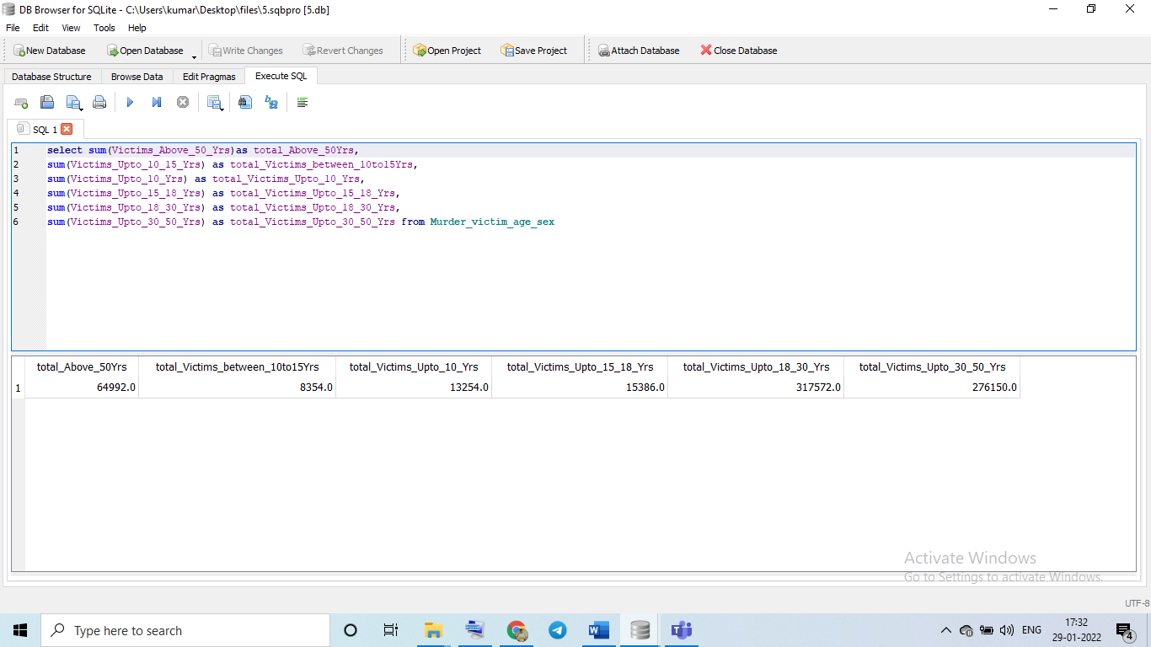

Conclusion –

* Highest murder victim are in age between 30 - 50.
* **Question6** - Crime by place of occurrence.

***SOLUTION***-

SQL QUERY-

**SELECT sum(RESIDENTIALPREMISES_Dacoity) as Total_RESIDENTIALPREMISES_Dacoity,  
sum(RESIDENTIALPREMISES_Robbery) as Total_RESIDENTIALPREMISES_Robbery,  
sum(RESIDENTIALPREMISES_Theft)as Total_RESIDENTIALPREMISES_Theft,  
sum(RESIDENTIALPREMISES_Burglary) as Total_RESIDENTIALPREMISES_Burglary,  
sum(HIGHWAYS_Burglary) as Total_HIGHWAYS_Burglary,  
sum(HIGHWAYS_Dacoity)as Total_HIGHWAYS_Dacoity,  
sum(HIGHWAYS_Robbery) as Total_HIGHWAYS_Robbery,  
sum(HIGHWAYS_Theft)as Total_HIGHWAYS_Theft,  
sum(RIVERandSEA_Theft) as Total_RIVERandSEA_Theft,  
sum(RIVERandSEA_Burglary) as Total_RIVERandSEA_Burglary,  
sum(RIVERandSEA_Dacoity) as Total_RIVERandSEA_Dacoity,  
sum(RIVERandSEA_Robbery) as Total_RIVERandSEA_Robbery,  
sum(RAILWAYS_Burglary) as Total_RAILWAYS_Burglary,  
sum(RAILWAYS_Dacoity) as Total_RAILWAYS_Dacoity,  
sum(RAILWAYS_Robbery) as Total_RAILWAYS_Robbery,  
sum(RAILWAYS_Theft) as Total_RAILWAYS_Theft,  
sum(BANKS_Burglary)as Total_BANKS_Burglary ,  
sum(BANKS_Dacoity) as Total_BANKS_Dacoity,  
sum(BANKS_Robbery) as Total_BANKS_Robbery,  
sum(BANKS_Theft) as Total_BANKS_Theft,  
sum(COMMERCIALESTABLISHMENTS_Burglary) as Total_COMMERCIALESTABLISHMENTS_Burglary,  
sum(COMMERCIALESTABLISHMENTS_Dacoity) as Total_COMMERCIALESTABLISHMENTS_Dacoity,  
sum(COMMERCIALESTABLISHMENTS_Robbery) as Total_COMMERCIALESTABLISHMENTS_Robbery,  
sum(COMMERCIALESTABLISHMENTS_Theft)as Total_COMMERCIALESTABLISHMENTS_Theft,  
sum(OTHERPLACES_Burglary)as Total_OTHERPLACES_Burglary,  
sum(OTHERPLACES_Dacoity) as Total_OTHERPLACES_Dacoity,  
sum(OTHERPLACES_Robbery) as Total_OTHERPLACES_Robbery,  
sum(OTHERPLACES_Theft) as Total_OTHERPLACES_Theft from Crime_by_place_of_occurrence_12**

RESULT OF QUERY:-

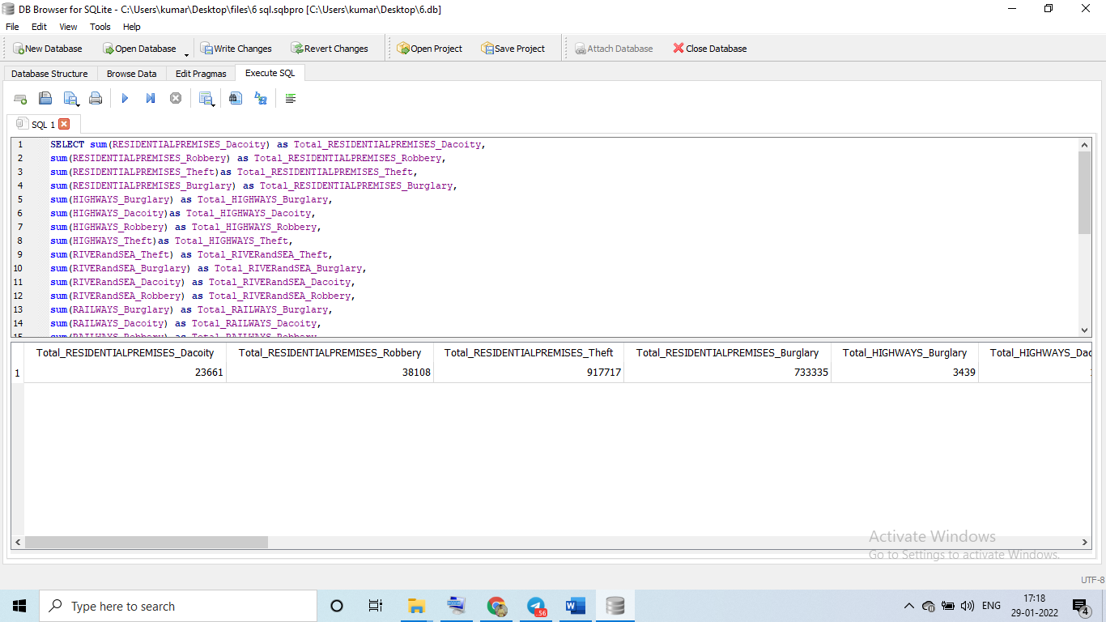

Visualization-

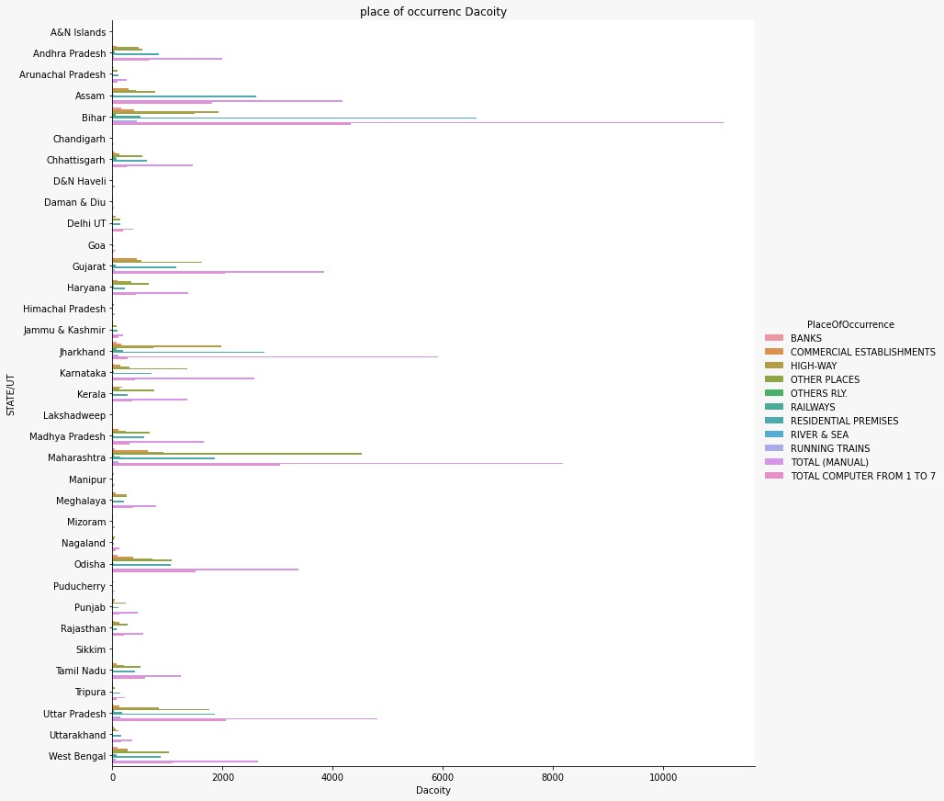

Conclusion-

* we can see highest crime of place are banks.
* highest crime of place are banks in Bihar.
* **Qustion7**- Anti corruption cases vs arrests.

***SOLUTION***-

SQL QUERY-

**SELECT DISTINCT A1.Area_Name,A1.AC02_No_of_cases_registered_during_the_year as "Cases registered",  
A2.ACA02_No_of_persons_arrested_during_the_year as "Criminals Arrested"  
FROM Anti_corruprion_cases as A1  
join Anti_corruption_arrests as A2  
on A1.Area_Name=A2.Area_Name  
GROUP by A1.Area_Name  
ORDER by A1.AC02_No_of_cases_registered_during_the_year desc;**

RESULT OF QUERY:-

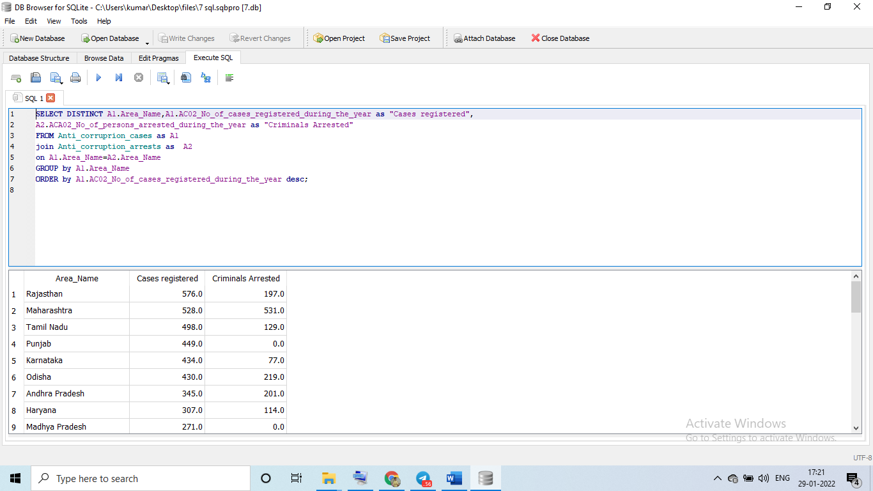

Visualization-

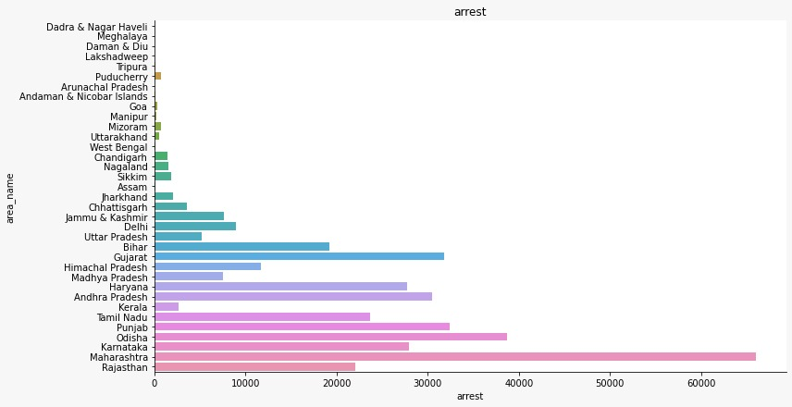

Conclusion-

* highest cases registered in Rajasthan.
* highest arrest in Maharashtra.
* **Qustion8**- Which state has more number of complaints against police?

***SOLUTION***-

SQL QUERY-

**SELECT STATE_UT,TOTALIPCCRIMES FROM District_wise_crimes_committed_IPC_2001_2012 GROUP by STATE_UT order by TOTALIPCCRIMES desc**

RESULT OF QUERY:-

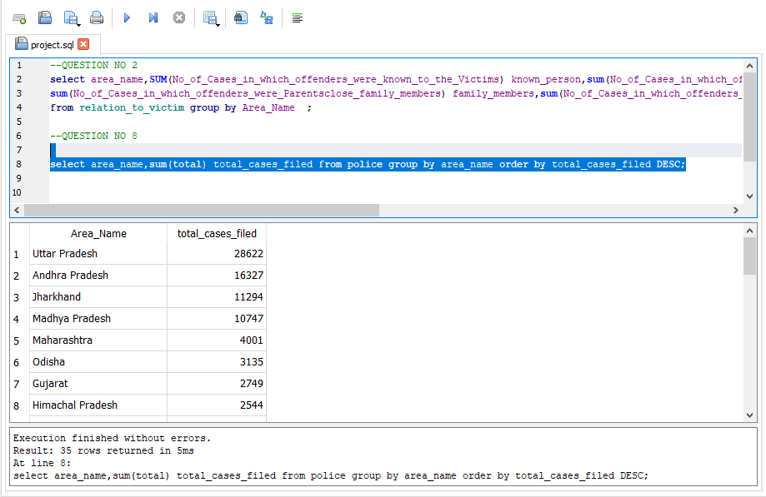

Visualization-

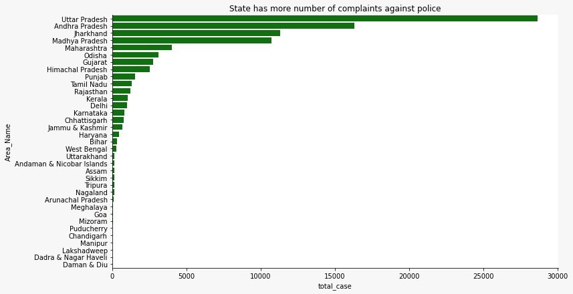

Conclusion-

* highest case against police is registered in Uttar Pradesh.
* **Qustion9** - Which state is the safest for foreigners?

***SOLUTION***-

SQL QUERY-

**SELECT "STATE/UT", sum(TOTALIPCCRIMES)as Total_ipc_Crime**

**FROM "01_District_wise_crimes_committed_IPC_2001_2012"**

**GROUP by "STATE/UT"**

**ORDER by TOTAL_ipc_Crime ASC**

RESULT OF QUERY:-

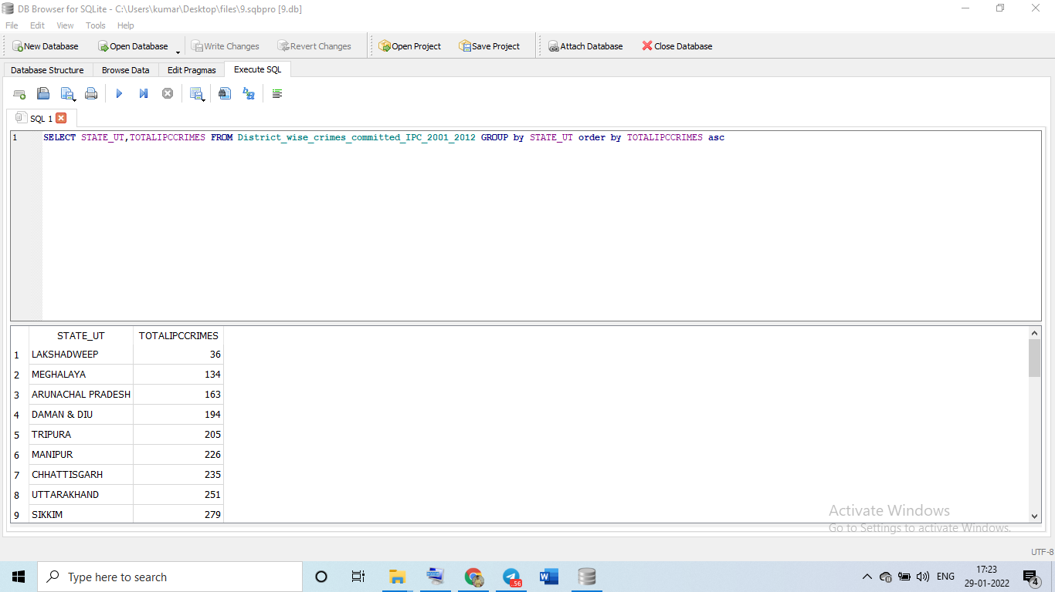

Conclusion-

* IPC crime record Madhya Pradesh has highest case record and Lakshadweep is lowest .
* So Lakshadweep is safest for foreigners because of lowest crime.